PROJECT

Stacked Deck ♠♥

♦♣

# Developed By: Chao Zhang

# Student ID: 000306946

# Faculty Advisor: Dennis Angle

# Date Submitted: April 17th, 2015

Background

Many people enjoy casual gambling, but the money spent on gas along with time on the road could be put to better use. I myself love watching poker online, but my friends are not as enthusiastic as I am about it. So it is difficult for me to get any hands on experience of playing it at a beginner level without travelling hours to the casino. I envision project *Stacked Deck* to be a simple online gambling site for people to enjoy at the comfort of their homes. It will allow members to order credits to play Blackjack. Not everyone understands the rules of the game, that’s why my website will feature a guest mode where people can play without spending money. But of course they don’t get any winnings either. I want this project to be something my friends and I could use to play together some day, also to just show them what I’ve learned at school. Creating something with real world applications is what I want to achieve with my capstone project.

Overview

Levels of permissions:

* Administrator (All-access)
* Members (Pay for credits to play)
* Guests (Free to play, no winnings)

Technologies used:

* HTML5
* CSS3
* Twitter Bootstrap
* JavaScript
* C#
* Microsoft SQL Server

Website Layout

Figure 1 – Login Screen

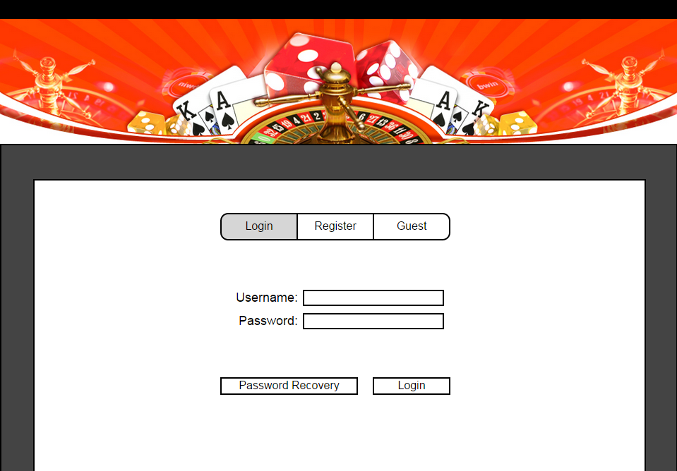

After initial load of the login page, the user will be greeted with the login screen (Figure 1). This screen consists of 3 tabs, user inputs with its labels and 2 buttons. The default selection will be the “Login” tab, highlighted in grey. Clicking the “Register” tab will switch views into the register screen (Figure 3). This does not navigate to another page. It will simply hide the login screen and show the register screen. Clicking the “Guest” tab will navigate to the home page (Figure 5) as a guest. Clicking the “Password Recovery” button will navigate to the password recovery page (Figure 23). After clicking the “Login” button, the user name and password inputs will be validated. If successfully validated, the user will be directed to the home page as the logged in user. When login fails, the input fields will be highlighted in red and an error message will be shown (Figure 2). The error message will indicate the reasoning behind the login fail.

Figure 2 – Login Error

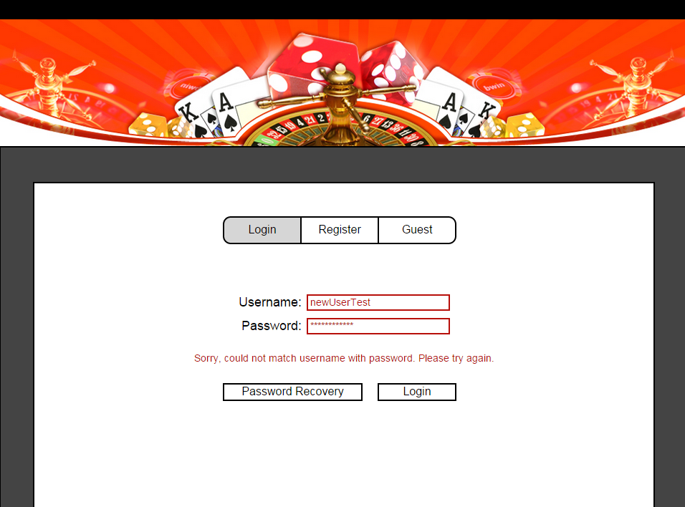

Figure 3 – Register Screen

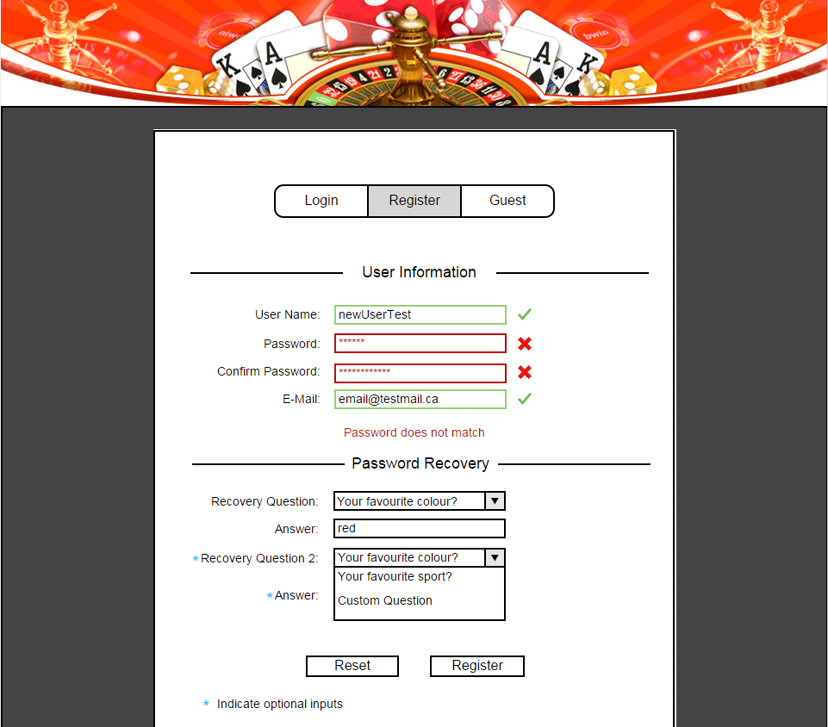

The register screen (Figure 3) has 2 sections, user information and password recovery. The user information section consists of 4 inputs that will have validation. The user name input will only allow letters and numbers, no special characters and spaces will be allowed. The password will have no restrictions in data, only a minimum length of 5 characters. E-mail will check valid e-mail formatting and if the address is already registered. The validations will be done by regular expressions. The password recovery section will contain 2 recovery question dropdown boxes along with their answer inputs. Only the first question is required, the second one is optional for the user. The user could choose from predetermined questions, or an option of creating a custom question. When the user selects the custom question options (Figure 4), a new input box will appear and the user can enter a custom question of their choice. There will be no restrictions on the custom question input. The answer inputs will not allow empty data or just blank spaces. Clicking the reset button will reset the form to default state with empty inputs. When all inputs are validated, the register button will insert new user record into database, user will then be redirected to login screen.

Figure 4 – Password Recovery Questions

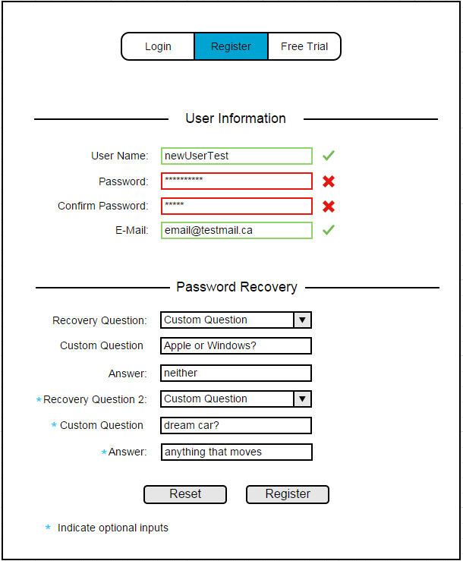

Figure 5 – Home Page



The homepage (Figure 5) will have a user indicator at the top right corner, a header banner, a welcome banner, horizontal navigate menu and a carousel. The user indicator will show guest or the logged in user’s user name. Clicking the indicator will log the user out and redirect to the login screen. The indicator and the header banner will remain the same throughout all the pages. The welcome banner will be below the navigate menu items. The carousel will consist of ads from a list that are created by the admin. Ads will rotate every few seconds to display another one in the list.

The menu items consist of:

* Home
* Games
* How to Play
* Special Offers
* Member Section - Members and Admin access level
* Purchases - Members and Admin access level
* Discussion – Members and Admin only
* Admin - Admin only

Figure 6 - Homepage Alternate Carousel



The how to play page (Figure 7) will have two sections. First section will be video tutorials that have embedded YouTube videos for the users to watch. The second section will contain text explanations on how to play Blackjack and card values. The videos can be played on the website itself with full screen capability.

Figure 7 - How to Play Page

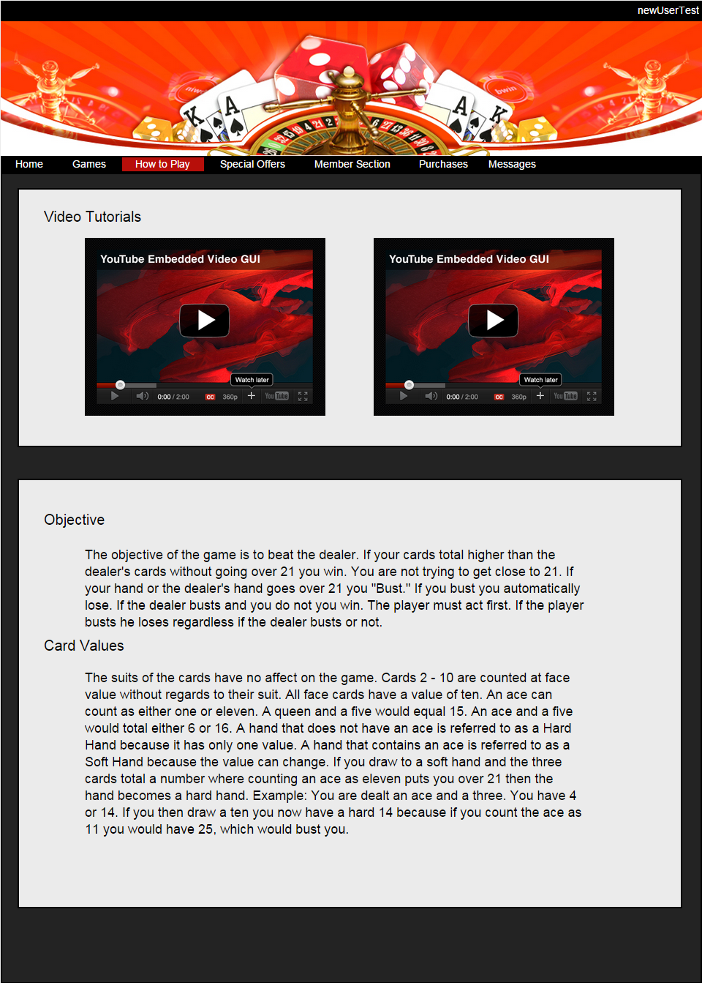

The special offers page (Figure 8) will have current promotions regarding deals on purchasing credits. These items do not have functionality, just display purposes. The two items in figure 8 are examples of possible promotion offers.

Figure 8 – Special Offers Page

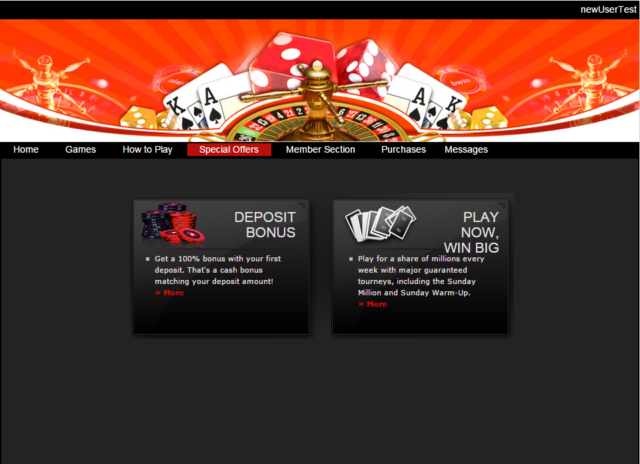

The members page (Figure 9) will have two sections, user information and contact information. The default state of the inputs and the save button will be disabled. When they click the edit button the inputs are enabled and user is able to change their password and e-mail address. The inputs will have the same requirements and validations as the inputs on the register screen. Clicking the save button will update the user information if all inputs are validated. Clicking the avatar will bring up a modal to choose avatar picture.

Figure 9 - Members Page

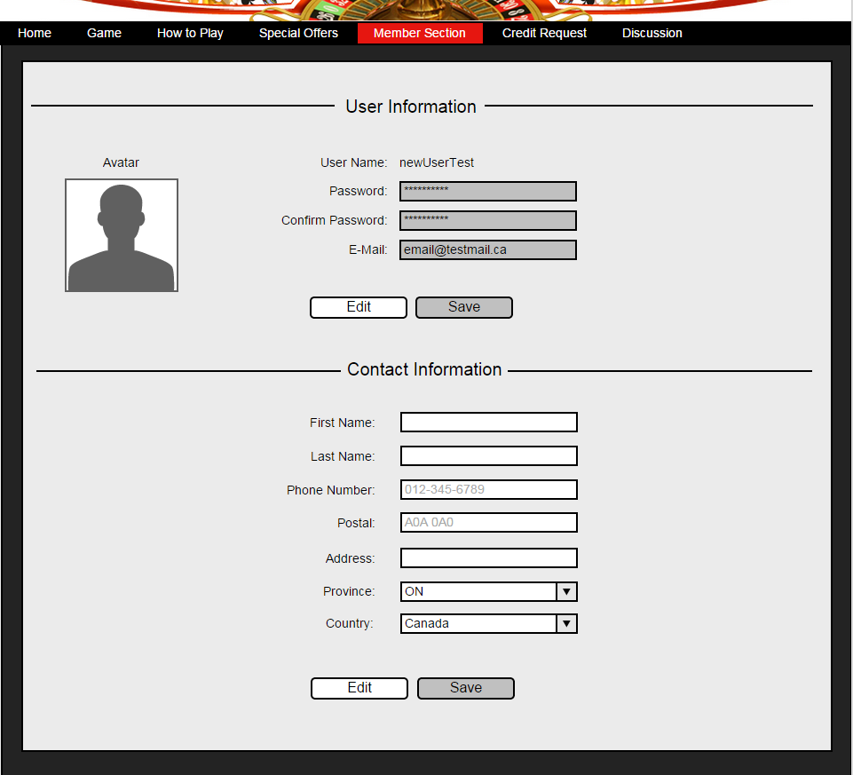

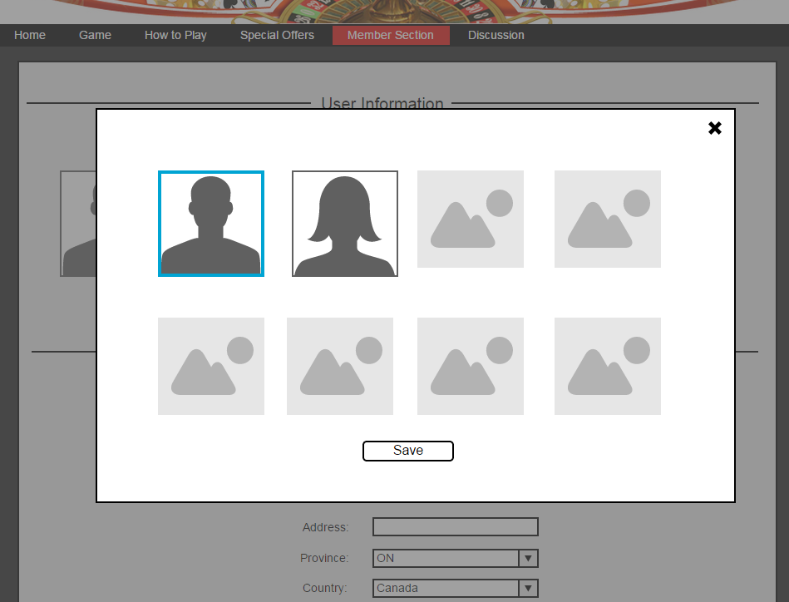

Figure 10 - Members Page Error

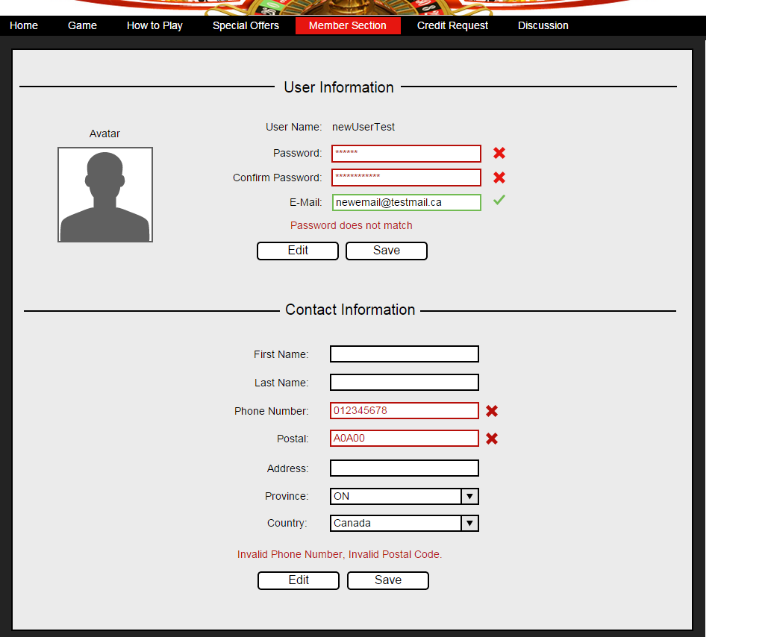

Figure 11 – Credit Request Page

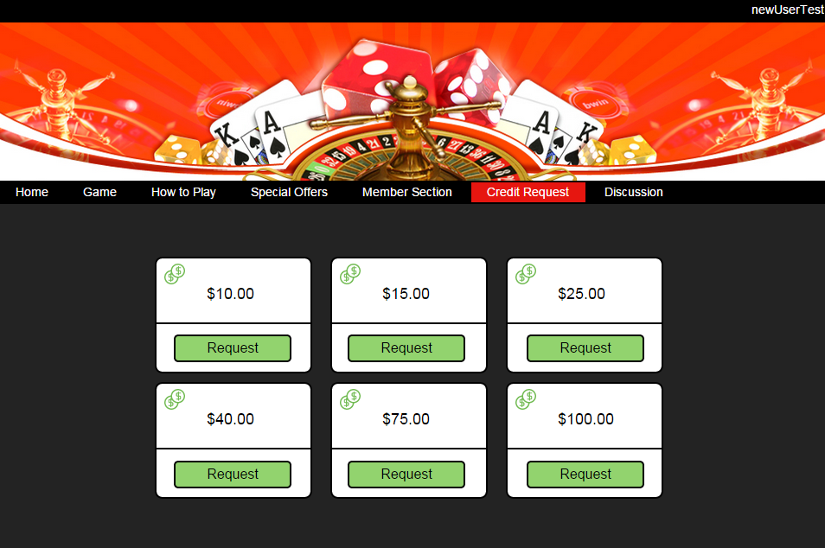

The credit request page will have 6 credit amounts that the user could request to be added to their account. After the user clicks an amount, the admin will receive the request that is pending approval.

On the game page (Figure 12), there are indicators on the left side showing the available credits and current winnings of the user. To start the game, the user must enter a bet amount into the input on the right side and click the deal button. The bet amount input box will only accept positive integers less than or equal to the user’s available credits (Figure 13).

Figure 12 - Game Page

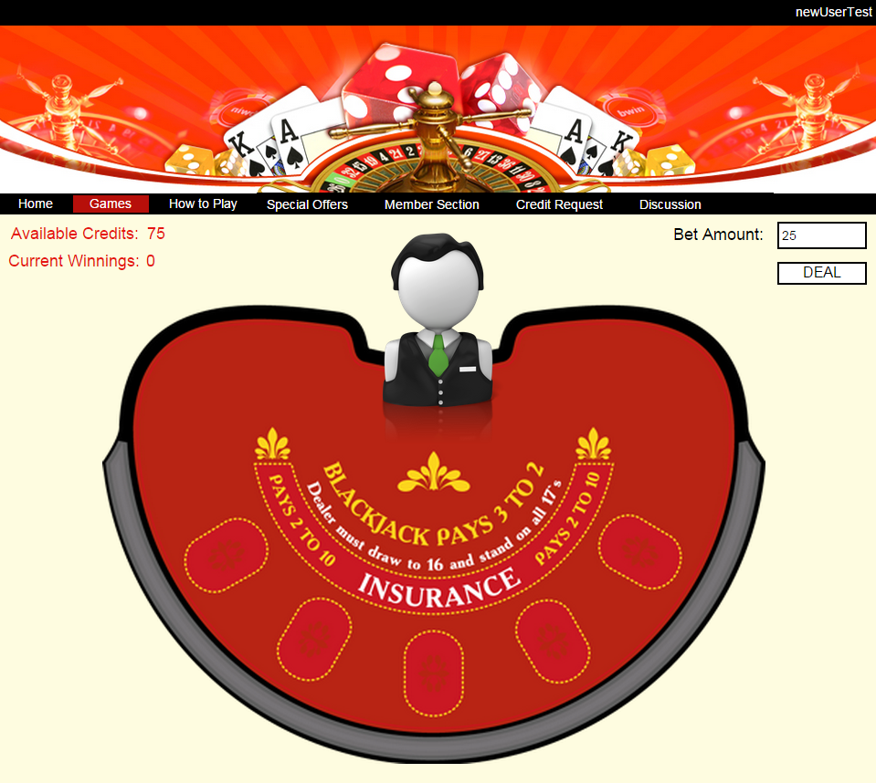

Figure 13 - Bet Amount Error

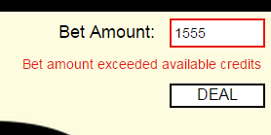

Figure 14 - Game in Progress

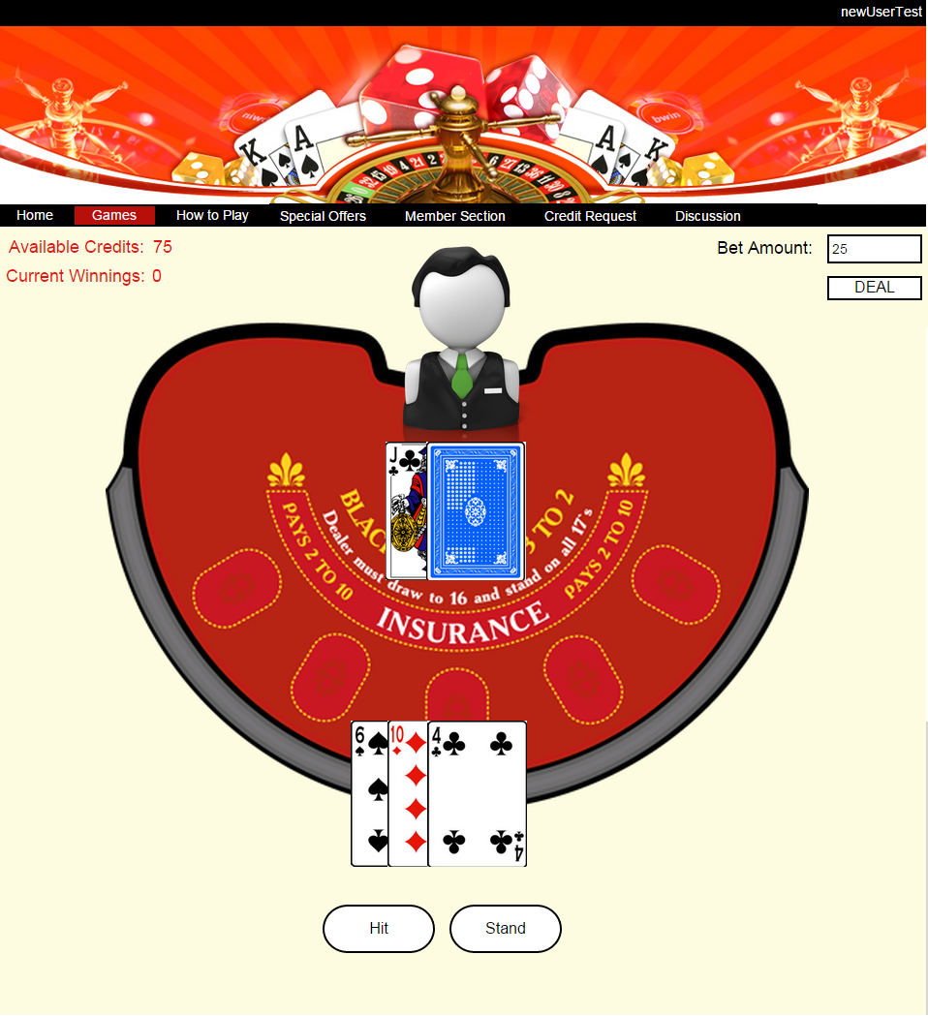

The game will be created by me with no plugins or other created code by others. After the game starts, cards are dealt to the user and dealer. Buttons will appear below the playing field based on available choices for the user. In Figure 14, the user already chose to “Hit” after the first round. The available choices now are to either “Hit” again or “Stand”.

Figure 15 - Game Over

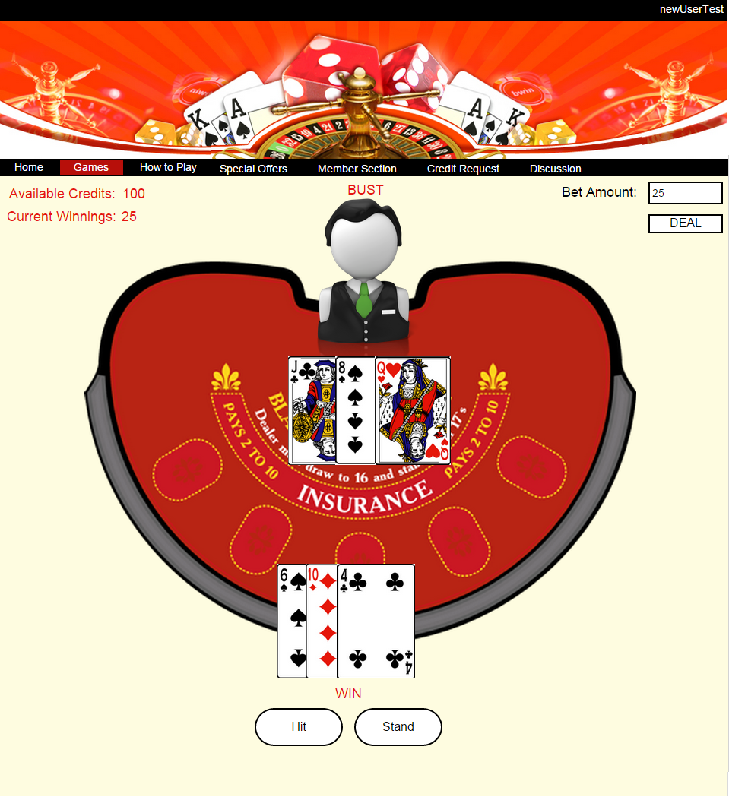

After the game is over, available credits and current winnings will update according to the results of the round. Figure 15 shows the end of a round when the dealer busts, resulted in a win for the user. The available credits and current winnings are now updated.

Figure 16 - Discussion Page

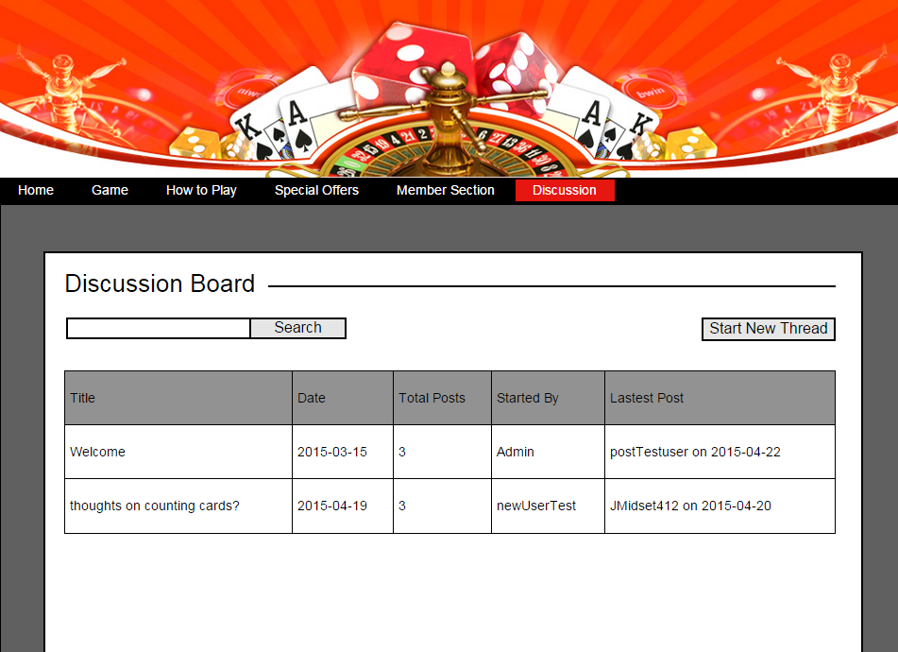

The discussion page (Figure 16) will display all the existing discussion threads. The search will look for matching string pattern in thread title, thread author and thread post text contents. Clicking on the title of the thread post open the specific thread page (Figure 18). Clicking the “Start New Thread” button will open a modal (Figure 17) with title and content inputs for a new thread.

Figure 17 - New Thread Modal

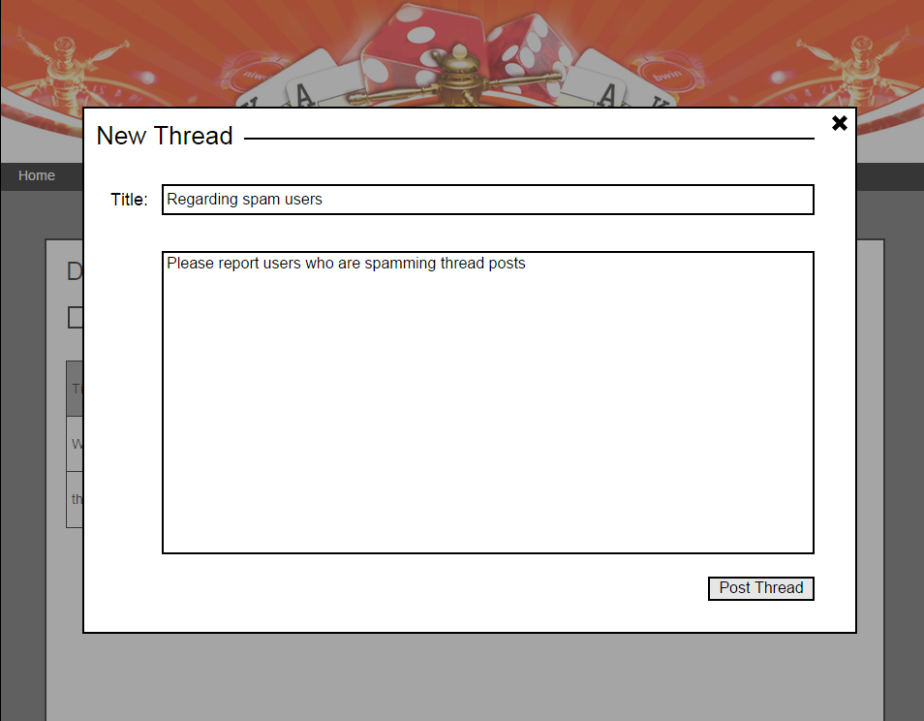

Figure 18 - Thread Post Page

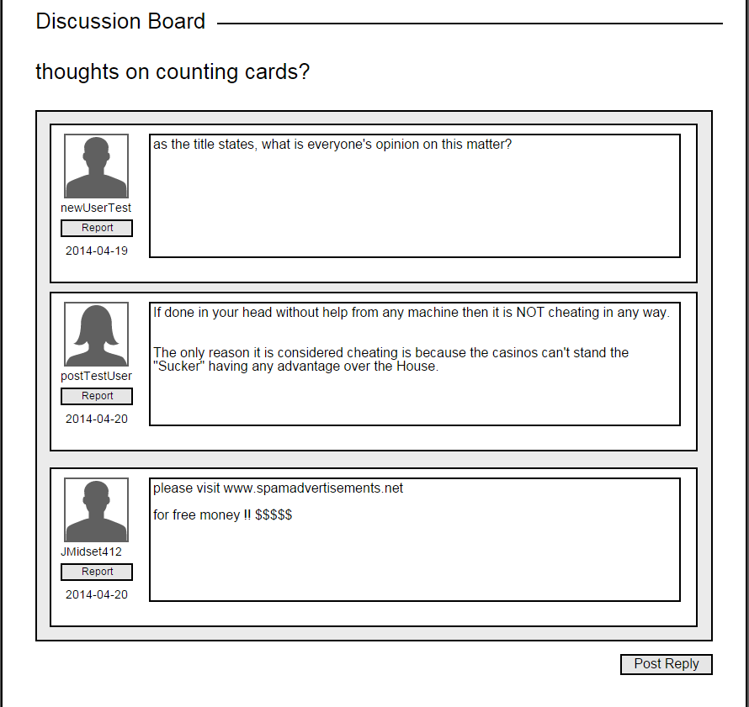

Clicking on the “Report” button will flag the post and add it to a list of flagged posts for Admin to review.

Figure 19 – Thread Post Reply

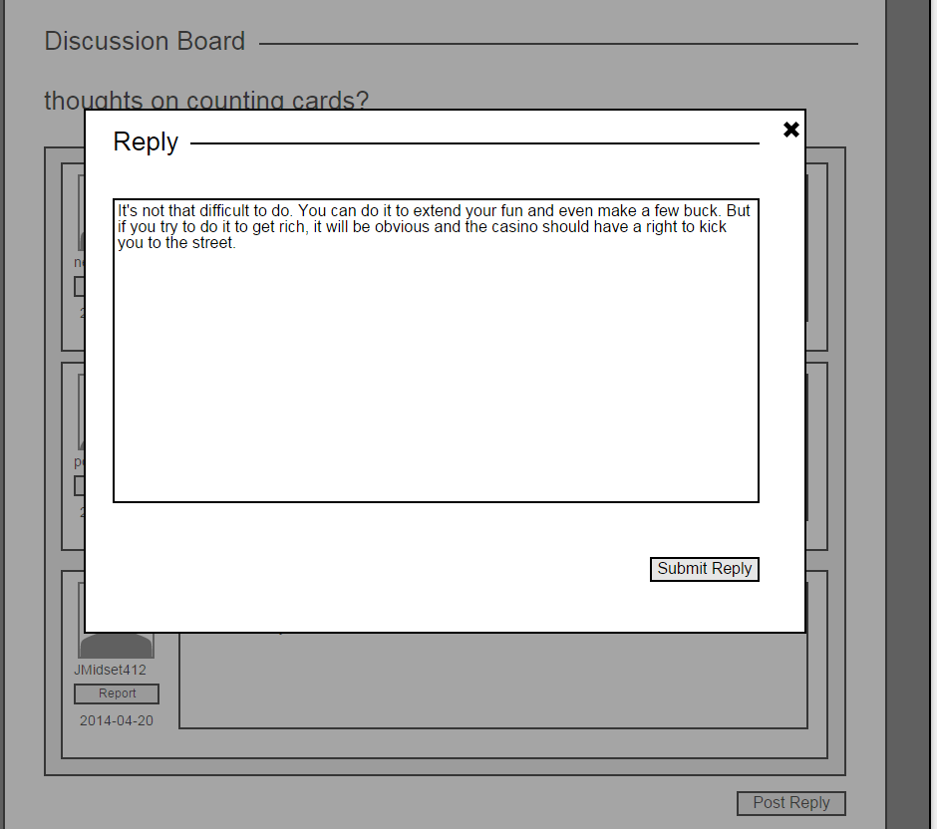

Figure 20 - Admin User Search

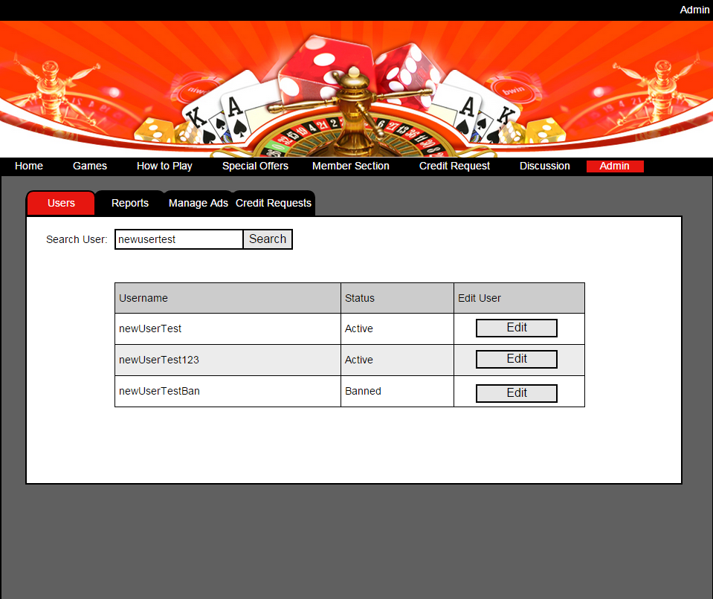

The admin page has three screens of different functionality. The first one is the users screen (Figure 16). On this screen, there is a search input for searching usernames to display in a table. The search string is not case sensitive and will return any results that contain the string. In this case, all the results contain “newusertest”. If the string is empty, the search will return all of the users. The table will display username, status of the user and a button to edit that user’s information.

Figure 21 - No Results

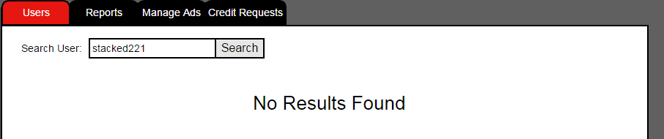

When the edit button is clicked for the specific user, a new modal window (Figure 18) will open with all of the user’s information to edit. All the inputs are disabled until the edit button on this screen is clicked. The inputs will have the same data requirement and validation as the register screen. An unban button will show up if the user is currently banned by the Admin

Figure 22 - Admin User Edit Modal

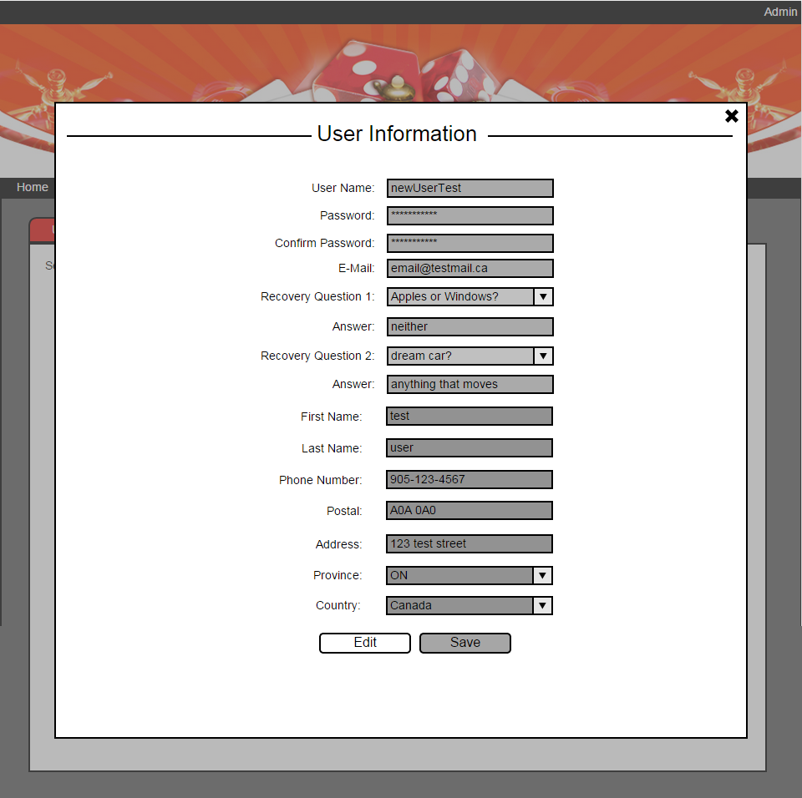

Figure 23 – Admin Reports

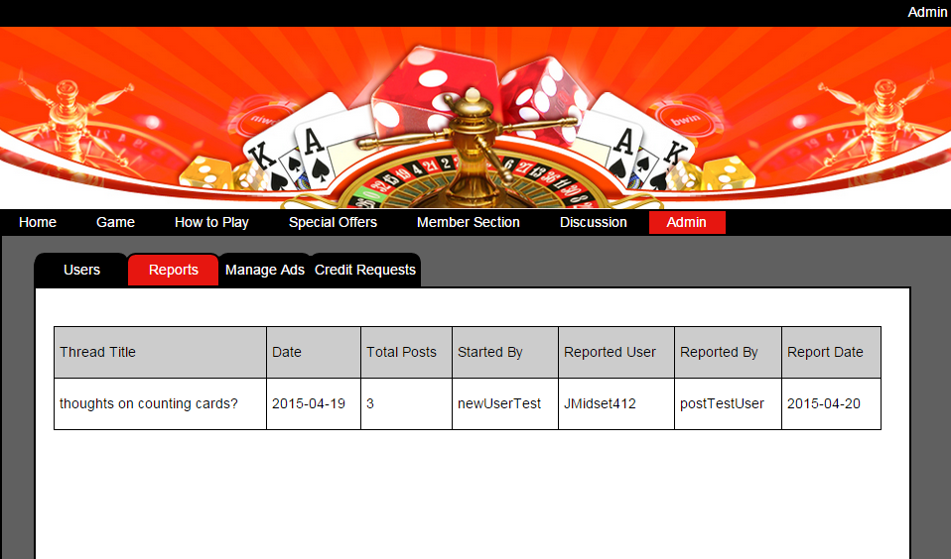

Figure 24 - Reported Posts

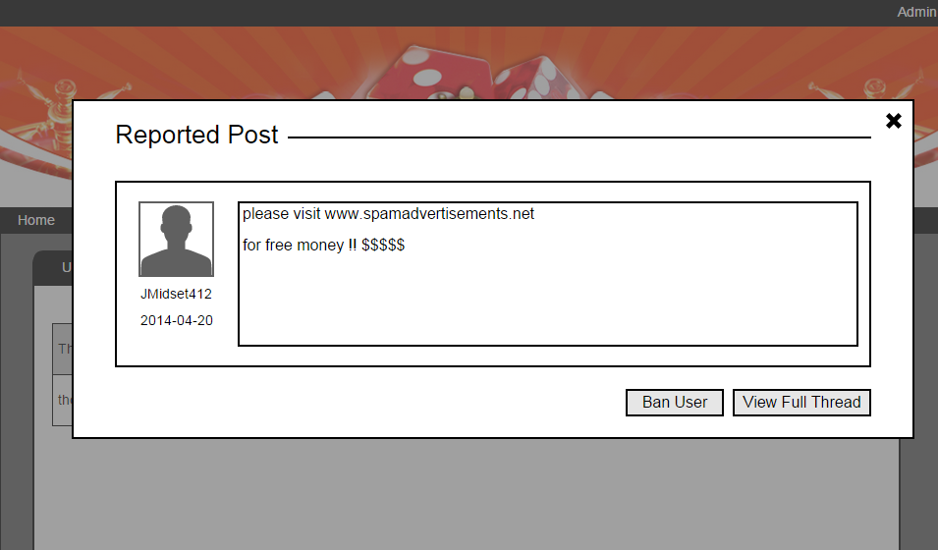

On the admin reports screen (Figure 23), the Admin will see a list of posts that have been flagged by users. Clicking on the thread title will open up the specific post (Figure 24). The admin could then ban the users or navigate to the original thread with all of its posts.

Figure 25 - Manage Ads

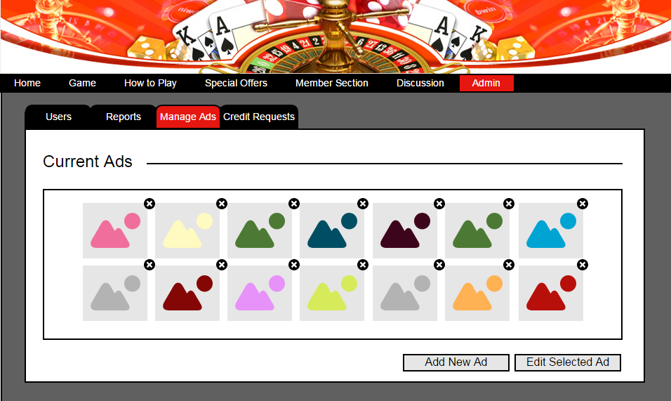

The ad manage screen (Figure 25) shows a list of all the existing ads on the home page. Clicking the “x” associated with an image will delete the ad. The admin can choose to create a new ad or edit an existing one. Clicking the “Add New Ad” button will open a modal (Figure 26) for the admin to choose an image and add text to it. Similarly, when the admin edits an ad, the same modal opens but with the selected image and prepopulated text.

Figure 26 - Create Ad

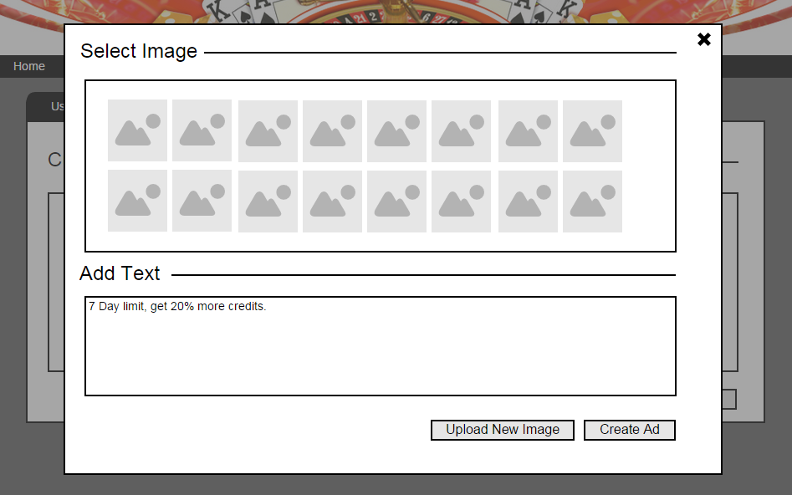

Figure 27 - Credit Request

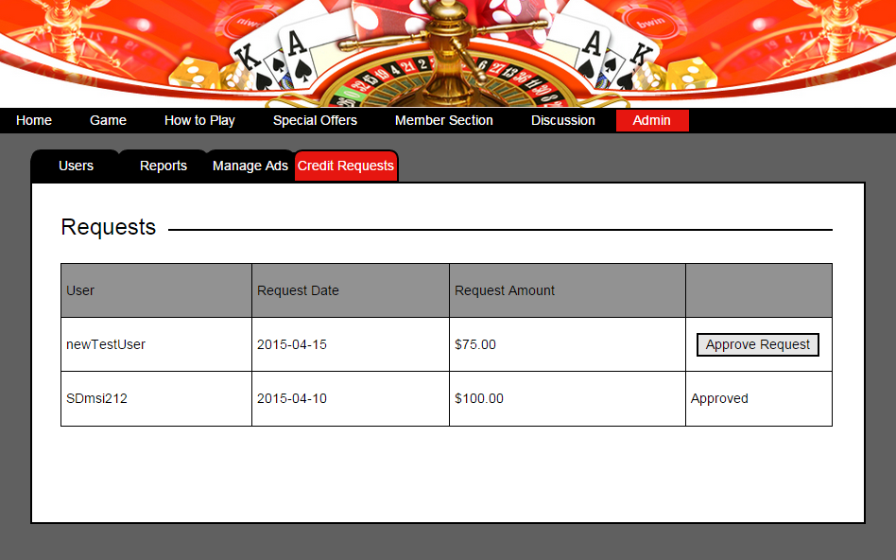

The credit requests screen (Figure 27) will display a list of pending requests to add credit to users’ account. When the admin approves the request, the button will change to approved.

Figure 28 - Password Recovery Page

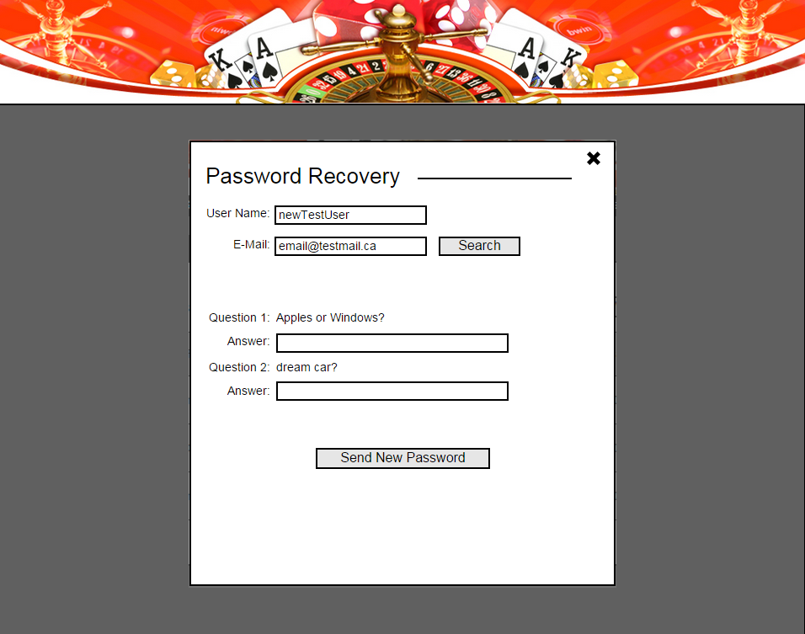

The password recovery page (Figure 28) has a user name and e-mail search input. This input will search for the password recovery questions associated with the user name and e-mail address. Then the questions will show up on the screen. If the user entered the correct answers for the questions, a new password will be generated and sent to the e-mail address. If the user name and e-mail address don’t match, there will be an error message. If the answers don’t match, there will also be an error message. The e-mail input will have format validation.

Figure 29 - Password Recovery Error

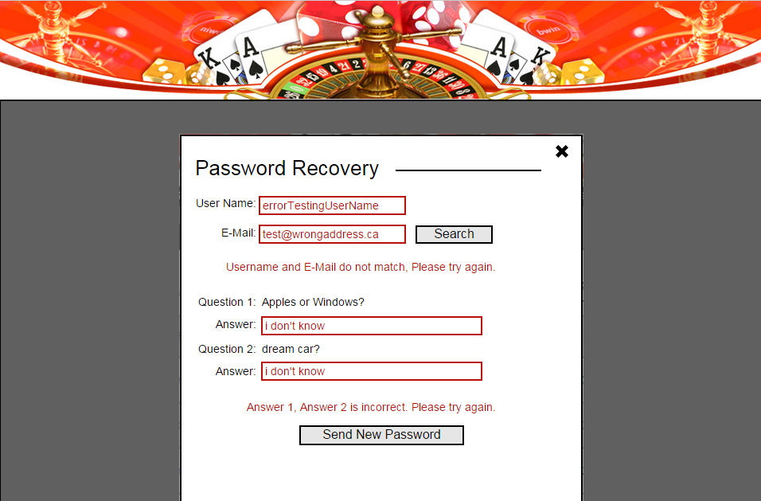

Stacked Deck Database Schema

|  |  |  |
| --- | --- | --- |
| SD_USERS | |  |
| USER_ID | INT - AUTO INCREMENT |  |
| USER_NAME | VARCHAR(50) |  |
| USER_PASSWORD | VARCHAR(50) - ENCRYPTED |  |
| USER_EMAIL | VARCHAR(50) |  |
| USER_RECOVERY_QUESTION | VARCHAR(50) |  |
| USER_RECOVERY_ANSWER | VARCHAR(50) |  |
| USER_RECOVERY_QUESTION_2 | VARCHAR(50) |  |
| USER_RECOVERY_ANSWER_2 | VARCHAR(50) |  |
| USER_STATUS | VARCHAR(10) | Active or Banned |
| USER_CREDIT | INT | Amount of credits |
| USER_TYPE | VARCHAR(10) | Admin or User |
| USER_FIRST_NAME | VARCHAR(50) |  |
| USER_LAST_NAME | VARCHAR(50) |  |
| USER_PHONE | VARCHAR(25) |  |
| USER_POSTAL | VARCHAR(10) |  |
| USER_ADDRESS | VARCHAR(50) |  |
| USER_PROVINCE | VARCHAR(50) |  |
| USER_COUNTRY | VARCHAR(50) |  |

|  |  |
| --- | --- |
| SD_ADVERTISEMENTS | |
| AD_ID | INT - AUTO INCREMENT |
| AD_TEXT | VARCHAR(100) |
| AD_IMAGE | VARBINARY(MAX) |
| AD_DATE | TIMESTAMP |

|  |  |
| --- | --- |
| SD_REQUESTS | |
| REQUEST _ID | INT - AUTO INCREMENT |
| USER_ID | INT |
| REQUEST_DATE | TIMESTAMP |
| REQUEST_AMOUNT | INT |

|  |  |
| --- | --- |
| SD_DISCUSSIONS | |
| DISC_ID | INT - AUTO INCREMENT |
| USER_ID | INT |
| DISC_TITLE | VARCHAR(100) |
| DISC_DATE | TIMESTAMP |
| DISC_CONTENT | VARCHAR(1000) |
| DISC_COUNT | INT |

|  |  |
| --- | --- |
| SD_POSTS | |
| POST_ID | INT - AUTO INCREMENT |
| DISC_ID | INT |
| USER_ID | INT |
| POST_DATE | TIMESTAMP |
| POST_CONTENT | VARCHAR(1000) |

|  |  |
| --- | --- |
| SD_BANS | |
| BAN_ID | INT - AUTO INCREMENT |
| POST_ID | INT |
| DISC_ID | INT |
| USER_ID | INT |
| REPORTED_USER_ID | INT |
| BAN_DATE | TIMESTAMP |

Database ERD

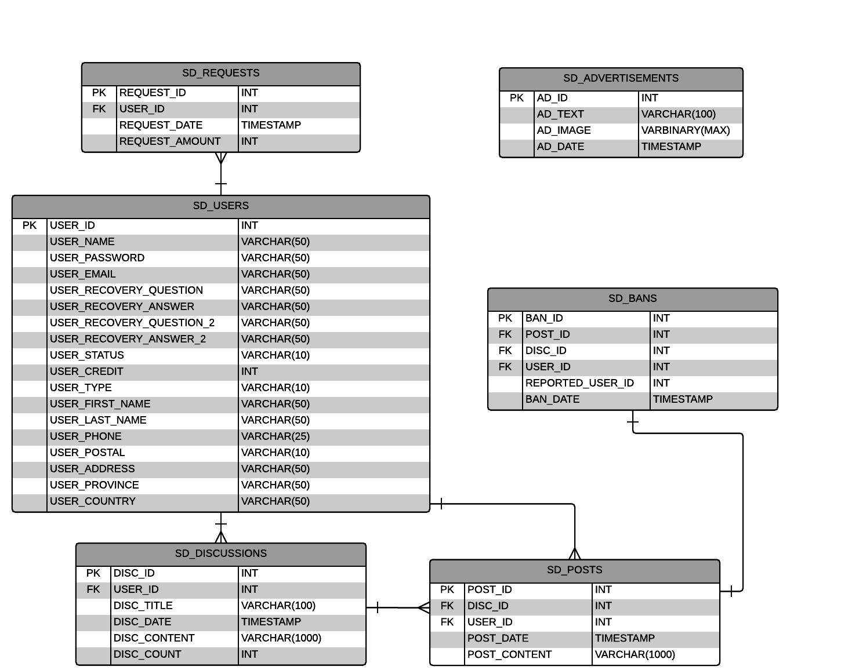

Testing Plan

*Test to Pass*

* Login
  + Proper login credentials
  + Login redirect
  + Logout redirect
* Registration
  + Proper data entry
  + Registration Redirect
* Homepage
  + Carousel redirect
* How to Play
  + Embedded videos playing
* Members page
  + Proper data entry
* Requests
  + Amount request added to user credit
  + Request approval by admin
* Game page
  + Correct game logic/winning condition
  + Proper bet amount
  + Winnings updating correctly
* Admin
  + User search showing results unless no user registered
  + User edit proper data entry
  + User status change
  + Ad management, create, edit
* Discussions
  + Create, report
* Password Recovery
  + Proper data entry
  + Questions auto populate

*Test to Fail*

* Improper data entry on all forms that have validation
* Creating existing user/using existing e-mail to register
* Improper page navigation based on restriction level

As the developer, I will be testing this project with irregular data trying to find as many security loop-holes as possible. I will be using Selenium to help with the testing. Black-box testing method will be done by beta testers. All testing will be done on Internet Explorer, Mozilla FireFox, Google Chrome and Safari. I will host a Google doc for all the testers to record bugs in.

Challenges

The biggest challenge of this project is the game portion of it. I need to account for all possible outcomes according to the rules of the game. The next biggest challenge will be the database portion. I need to make sure all the data types are appropriate for the scope of this project. I am not as familiar with back-end technologies as I am with front-end. I need to put extra effort into this portion to make sure the procedures and queries are correct along with data encryption. The last thing I’m concerned with is the validation part of this project. I will be working with regular expressions with form validation and algorithms for different types of data needed to validate.

Resources

<https://msdn.microsoft.com/en-ca>

<http://en.wikipedia.org/wiki/Blackjack>

<http://getbootstrap.com/>

<https://jquery.com/>

<https://msdn.microsoft.com/en-us/library/bb545450.aspx>

<http://www.browserstack.com/>

<https://www.google.ca/>

Project Planning

|  |  |  |
| --- | --- | --- |
| Week 1  Sept 8th - Sept 13th |  | * Create project foundation on Visual Studio * Create SQL Database with all tables * Create starter files for all webpages |
| Week 2  Sept 14th – Sept 20th |  | * Establish database connection * Start creating all the layout of every page   + Login Page   + Home Page   + Special Offers Page |
| Week 3  Sept 21st – Sept 27th |  | * Continue website layout   + How to Play Page   + Members Page   + Request Page |
| Week 4  Sept 28th – Oct 4th |  | * Continue website layout   + Game Page   + Admin Page   + Discussion Page   + Password Recovery Page * Start development on Blackjack game |
| Week 5  Oct 5th – Oct 11th |  | * Continue development on Blackjack game * Start development on functionality   + Login Page with SQL procedures   + Home Page   + How to Play Page |
| Week 6  Oct 12th – Oct 18th |  | * Continue development on Blackjack game * Continue development on functionality   + Members Page   + Request Page with SQL procedures |
| Week 7  Oct 19th – Oct 25th |  | * Continue development on Blackjack game * Continue development on functionality   + Admin Page searches with SQL procedures |
| Week 8  Oct 26th – Nov 1st |  | * Continue development on Blackjack game * Continue development on functionality   + Password Recovery Page searches with SQL procedures   + Discussion page |
| Week 9  Nov 2nd – Nov 8th |  | * Continue development on Blackjack game   + Update credits and winnings |
| Week 10  Nov 9th – Nov 15th |  | * Finish up any leftover pages * Start alpha testing * Start beta testing |
| Week 11  Nov 16th – Nov 22nd |  | * Continue alpha testing * Continue beta testing |
| Week 12  Nov 23rd – Nov 29th |  | * Finish alpha testing * Finish beta testing * Start fixing outstanding issues |
| Week 13  Nov 30th – Dec 6th |  | * Start presentation prep * Continue fixing outstanding issues |
| Week 14  Dec 7th – Dec 13th |  | * Finish fixing outstanding issues * Finish project * Finish presentation |